California State University, Northridge

College of Engineering & Computer Science

Electrical and Computer Engineering Department

ECE 443L Digital Electronics Laboratory Report 8

CMOS Based DAC Circuit



By Evan Thomas, Haroutun Haroutunian

Abstract: After constructing the Digital-to-Analog Converter, students examine the Pulse Voltage supplies to alter input frequencies. Input frequencies alter the pulse, as seen in the output figures in Procedure.

Keywords: DAC, MSB, LSB, non-inverting

**8.1 Introduction**

Experiment 8 introduces students to Digital-to-Analog Circuits. DACs are found in every electronic device, eg. Smartphones to convert volume on speakers, etc. The circuit consists of simple resistors, OpAmp, Voltage supplies to create inputs, and PMOS and NMOS transistors.

**8.2 Simulation and Experimental Set-up**

As seen in figure 8.1, the circuit is set up with common source and gate transistors. The circuit is set up where the Left-most is the Most Significant Bit, and the Right-most is the Least Significant Bit.

**8.3 Simulation and Experimental Results**

Figure 8.1 Case 1 Evan DAC circuit running at 5kHz, 2.5kHz, and 1.25kHz

Figure 8.2 Case 1 Evan output of DAC circuit

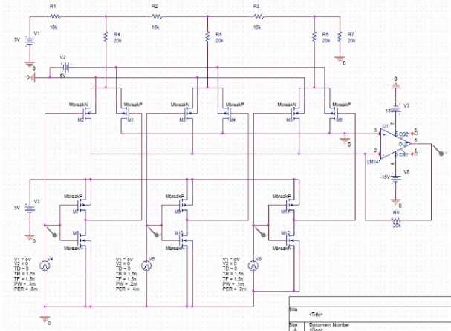

Figure 8.3 Case 2 Haroutun DAC circuit running @ LSB 5kHz, 2.5kHz and MSB 1.25kHz

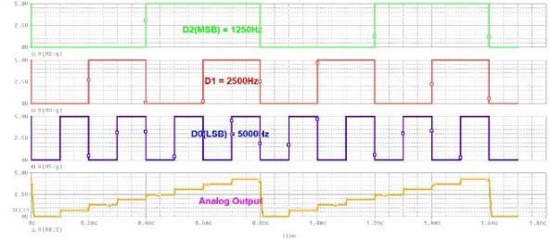Figure 8.4 Case 2 Haroutun

DAC circuit output @ LSB 5kHz, 2.5kHz and MSB 1.25kHz

Figure 8. 5 Case 3 Evan non inverting DAC circuit running at 3375 Hz, 6750 Hz, and 13500 Hz

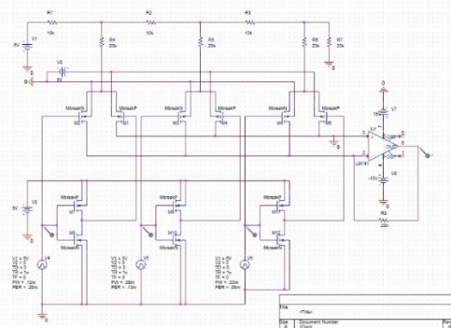Figure 8.6 Case 3 Evan DAC output of DAC circuit

Figure 8.7 Case 4 Haroutun DAC circuit running @ LSB 15kHz, 7.5kHz and MSB 3.75kHz

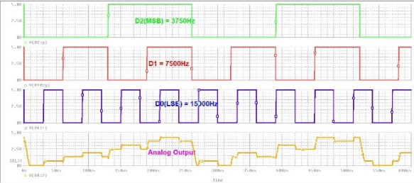

Figure 8.8 Case 2 Haroutun DAC circuit output @ LSB 15kHz, 7.5kHz and MSB 3.75kHz

Figure 8.9 Case 3 Experimental output of DAC Circuit

**8.4 Discussion and Conclusion**

In experiment 8, students were exposed to the set-up and uses of DAC circuits. DAC is utilized in everyday electronic devices so real-world inputs can be read by the electronic device and output easy-to-read waveforms. The music industry is surrounded by DAC circuits since frequencies are input in analog or digital and converted.